CSS CHEATSHEET

CSS SELECTORS

SELECTORS

Simple selectors
Select element based on name, id, and class

Combinator selectors
Combinator is something that defines the relationship between two or more elements.

Descendant combinator (space)
It matches all elements that are descendants (children, grandchildren, etc.) of specified element.

Child combinator (>)
It matches all elements that are direct children of a specified element.

Next sibling combinator (+)
It selects an element that is directly after a specified element. They must both have same parent.

Subsequent-sibling combinator (~)
It selects all elements that are the next siblings of a specified element. The siblings must all have the same parent.

Pseudo-class selectors
CSS pseudo-class is a keyword that can be added to a selector, to define a style for a special state of an element.
Syntax:

Interactive pseudo-class
- :hover (when mouse over an element)
- :focus (when an element has focus)
- :active (when an element is being activated)
- :link (unvisited link)
- :visited (visited link)

Structural pseudo-class
- :first-child (First child of a parent)
- :last-child (Last child of a parent)
- :nth-child(n) (Counts all children of the parent)
Example:
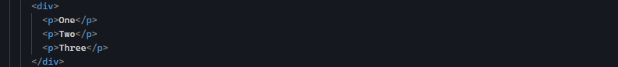
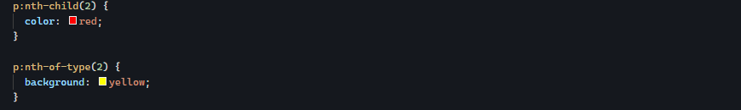
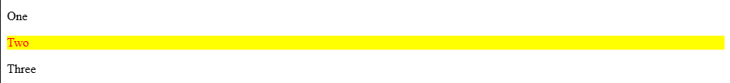
The children are
- :nth-of-type(n) (Counts only children of the same HTML tag)
Example:
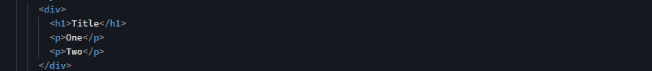
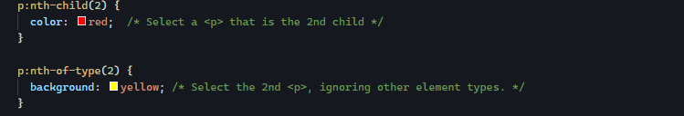
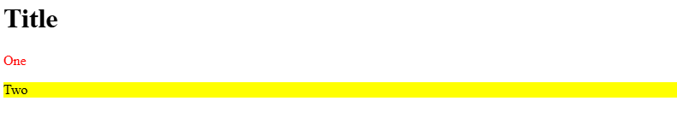

Pseudo-element selectors
A CSS pseudo-element is a keyword that can be added to selector, to style a specific part of element.
Syntax:
Some common use of pseudo-elements:
- Style the first letter or first line, of an element
- Insert content before or after an element
- Style the markers of list items
- Style the user-selected portion of an element
- Style the viewbox behind a dialog box.

CSS Pseudo-elements for text
They allow you to style specific part of text content, such as first line or first letter.
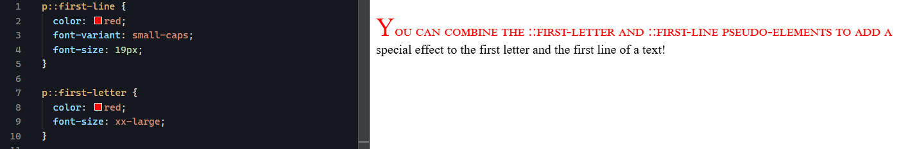

CSS Pseudo-elements for content
They allow you to insert content before or after elements, style list markers and more
The ::before pseudo-element is used to insert some content before the content of a specified element.
The ::after pseudo-element is used to insert some content after the content of a specified element.
User the content property to specify the content to insert for both case.
The ::backdrop pseudo-element is used to style viewbox behind a dialog or popover element

Attribute selectors

BACKGROUND

Background-mage
It specifies an image to use as the background of element.
By default:
- The image is repeats (background-repeat: repeat)
- It starts at the top-left (background-position: 0% 0%)
- It keeps its original size (Background-size: auto)

Common property used with background-image
- Background-size:
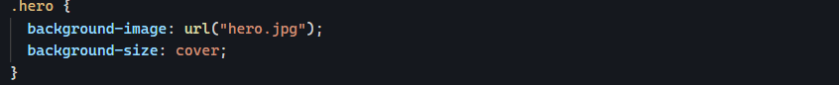
Controls how large the background image appears.
Common values:
- Fills the entire element
- May crop part of the image
- Best for hero sections, banners, cards
- Shows the entire image
- May leave empty space
- Set exact dimensions (Width and Height)
- Background-position
Controls where the image sits.
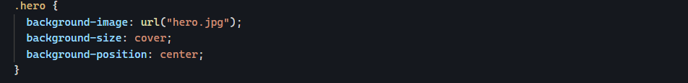
Common values:


Background-attachment
It specifies whether the background image should scroll or be fixed (will not scroll with the rest of the page).
Specify the background image should be fixed.
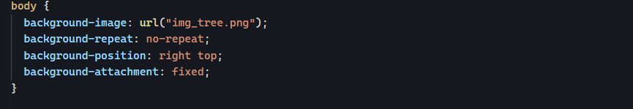
Specify the background image should scroll
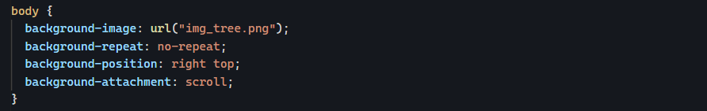

Background shorthand
Background-color background-image background-repeat background-position

PADDING AND BOX-SIZING
Box-sizing property defines how the width and height of an element are calculated. Should they include padding and border, or not.
Common values:
- Content-box: This is the default. The width and height property includes only the content (border and padding are not included)
- Border-box: the width and height properties include content, padding and border

